Streamlined Energy and Carbon Reporting
UK Greenhouse gas emissions and energy use data for the period 1st August 2024 to 31st July 2025 | 2024 / 2025 | 2023 / 2024 | Movement %
Energy consumption to calculate emissions (kWh) (gas, electricity, fuel) | 3,698,181 | 3,597,019 | 3
Scope 1. Emissions in metric tonnes Co2e. (direct emissions from owned sources or control directly) | 326 | 344 | -5
Scope 2. Emissions in metric tonnes Co2e. (indirect energy purchase) | 400 | 361 | 11
Scope 3. Emissions in metric tonnes Co2e. (indirect business travel in employee-owned vehicles) | 70 | 72 | -3
Total gross emissions in metric tonnes CO2e | 796 | 777 | 2.5
Intensity ratio Tonnes CO2e per staff member. | 715 / 1.11 | 702 / 1.10

East Lancashire Learning Group (ELLG) is committed to reducing its carbon emissions and has taken the following measures in the year to improve efficiency:
- Continue to promote energy saving measures across ELLG campuses including actively managing heating temperatures
- Renegotiated the energy supplier tariffs to secure competitive pricing.
- Consolidated ELLG vehicle visits/deliveries between sites utilising our EV wherever possible.
- Started solar PV installation across Nelson and Accrington campuses as part of our Public Sector Decarbonisation Scheme.
- Commenced installation of air source heat source pumps across the two main estates.
- Promote the continued use of Teams across ELLG to reduce travel between sites including Leadership and CPD sessions.

Quantification and reporting methodology


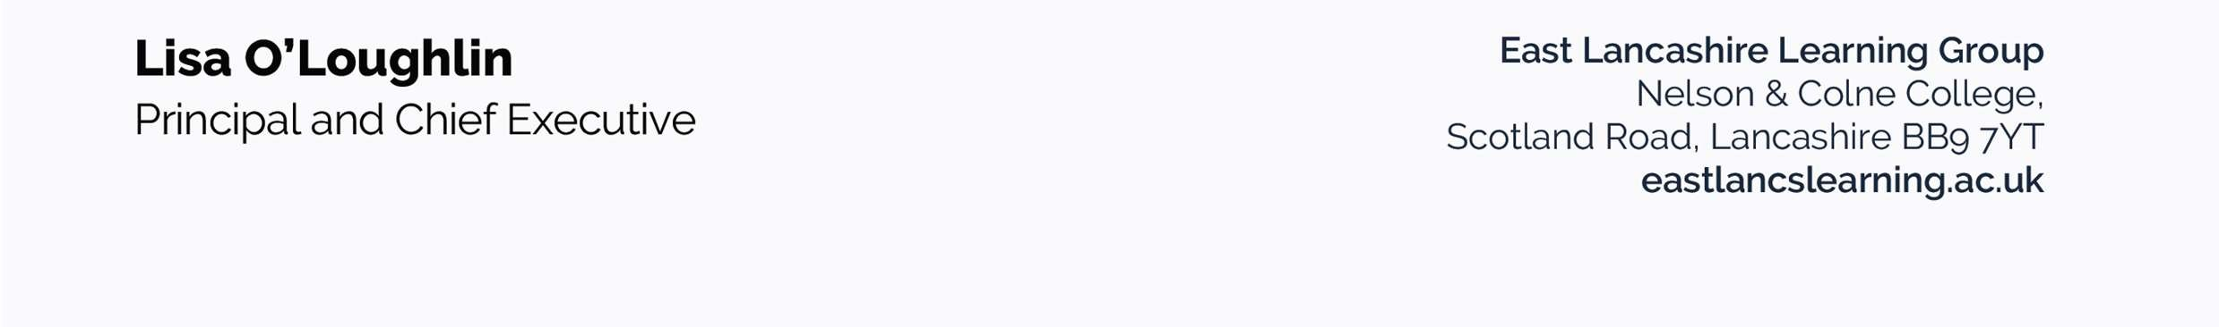
ELLG has followed the 2019 HM Government Environmental Reporting Guidelines, the GHG Reporting Protocol – Corporate Standard, the 2024 UK Government's Conversion Factors for reporting. The chosen intensity measurement ratio is total gross emissions in metric tonnes CO2e per onsite staff member, the recommended ratio for the sector.

