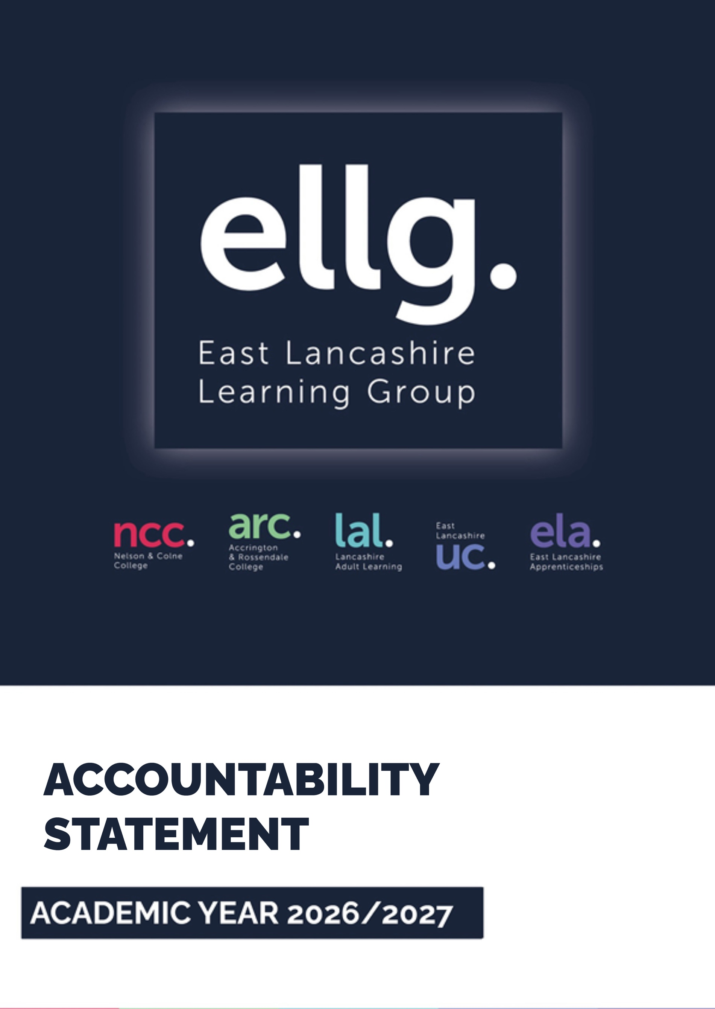
Overview
East Lancashire Learning Group aims to ‘create the extraordinary’ in all we do, and this ambition and drive has led the Group to be one of the highest-achieving colleges in the country with a deserved track record and reputation for quality, innovation and excellence. Ofsted ‘Outstanding’ since 2005, our latest inspection in 2024 confirmed us as the only ‘Outstanding’ Further Education college in Lancashire and the only college in the country to have been ‘Outstanding’ for 20 years.
Working closely with employers, partners and stakeholders, we develop and deliver a high-quality and innovative curriculum focused on delivering against the skills priorities identified at national level and in the Lancashire Skills and Improvement Plan (LSIP) - to meet the needs and ambitions of the learners, communities and businesses we serve.
East Lancashire Learning Group has a turnover of £39 million, was formed by merger in 2018 and includes:
- Nelson and Colne College
- Accrington and Rossendale College
- Lancashire Adult Learning (LAL)
Nelson and Colne College has a national reputation for academic educational success and is seen within the sector as a beacon of excellence for teaching and learning. Accrington and Rossendale College is a hub for technical and professional skills delivery for 16-18 students, adult learners and apprentices.
Lancashire Adult Learning (LAL) is the third largest adult community learning provider in the country – providing exceptional learning opportunities throughout the whole of Lancashire.
In 2024-5 East Lancashire Learning Group established its apprenticeship delivery unit, East Lancashire Apprenticeships. The development of this delivery arm has resulted in an increase in both volumes of apprentices in key sectors and in the timely achievement of its apprentices.
Following a thorough and evidence based Strategic Review in 2023, a significant investment in the development of curriculum to meet participation and skills gaps has taken place. As a result, new curriculum has been established at levels 2 and 3 at both colleges, aligned to the UK Modern Industrial Strategy and the Local Skills Improvement Plan. Underpinning these developments, is an associated investment and estates strategy, focused on enabling growth in technical education. From September 2023 to September 2026 this will see the college investing circa £15 million in its estate to ensure it continues to offer a relevant, impactful and high-quality curriculum that responds to individual, regional and national needs.

OUR VISION
To build stronger communities and create high quality routes into high-value professional and technical careers for all our learners.

1. Purpose

East Lancashire Learning Group (ELLG) is a high-performing, ambitious organisation. Expertly led by a strong leadership team headed by Lisa O’Loughlin; the College’s Staff, Governing Board and leadership set and drive challenging targets. Through passion, creativity, rigour and diligence, year on year we are delivering financial improvements, growth in key sectors and priority programmes, whilst also and most importantly delivering highly successful, industry-ready students and apprentices. In December 2024, the group was recognised as Outstanding by Ofsted, making it the only Further Education College in Lancashire to have achieved this status and the only college in the country to have retained Outstanding status for 20 years. In 2024/25, the Group further consolidated its position as a high-quality provider, realising improved achievement rates in all provision types and becoming the no 1 GFE in the country for 16-18, adult and overall achievement.
At East Lancashire Learning Group, we recognise that NARTs rankings are impacted by a college’s mix and balance of provision, so our key drivers of success are student progress and destinations. In 2024/25 East Lancashire Learning Group was the number 1 GFE in the country for A Level, Academic and Technical progress and the number 1 GFE in the region for Applied General and Advanced Apprenticeship progress. Our sustained destination rates for adults, including some of the most vulnerable in our communities, is 91%, 4ppts above the national rate and our 16-18 sustained destination rate is 95%, 16ppts above the national rate. The college’s reputation for high-quality delivery through evidence-based practice, has resulted in us becoming an EEF Post-16 research partner in 2025/26 and a delivery partner of the NW Construction CTEC, working alongside Wigan and Leigh College and Blackpool and the Fylde College.
The success of our communities, employers, partners and economy sits at the heart of all we do. We have forged valuable partnerships and a shared vision with like-minded organisations, employers and individuals, creating a network of opportunity and excellence for our students. Our highly-skilled staff are committed to raising and supporting aspirations, providing social mobility and creating an essential talent pool for the local, regional and national economy. Through sectoral Industry Boards our technical and vocational programmes are co-created with regional employers, many of which accept students on to work and industry placements, in addition to providing mentoring and co-delivery, so that all our students have an industry/employer aligned education. As part of our 2023 Strategic Review and to ensure qualification reform transition readiness, we have established a strong co-creation strategy activated through our industry boards; a partnership team and our people strategy, where we are successfully filling key roles through initiatives such as the Industry Associates Programme and the CTEC-led Teacher Industry Exchange Programme.
The College is also recognised as a high-quality and trusted organisation at a national level, resulting in senior members of the leadership team becoming involved in the co-creation of national policy including participation in the Curriculum and Assessment Review, the Milburn Review, the Teacher Training and Development Expert Advisory Group and the Maths to 18 Expert Advisory Group. Most recently, the college was invited to become a DFE Qualification Pioneer organisation, supporting the Skills Minister and Department for Education in the realisation of their ambitious vision, as set out in the Post 16 Skills White Paper.
In 2013, the College became sponsor of the Pendle Education Trust, comprising of three primary schools and two secondary schools. The Trust is now delivering very good progress, and our primary schools are now rated ‘Good’ by Ofsted.
PURPOSE ARCHITECTURE
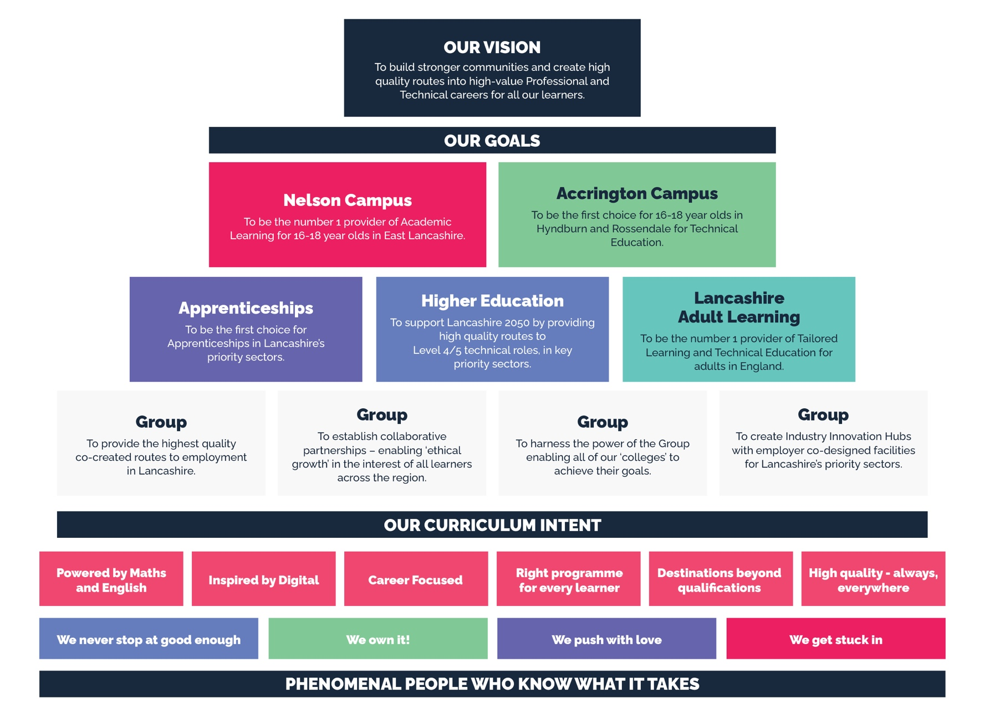

COLLABORATION
The College is part of The Lancashire Colleges group (TLC); a collaborative network, for over 25 years. TLC includes all of the Further Education and Sixth Form Colleges in the region, including a specialist land-based college and represents the diversity of the sector as a whole. East Lancashire Learning Group recognises the value of working with other education and skills providers in East Lancashire and the wider Lancashire region to review how well our provision is collectively meeting local needs.
Our shared ambition, as part of TLC, is to ensure that, together, we deliver a curriculum and progression pathways that serve the local community, while building on individual strengths and specialisms to maximise collective impact and meet business needs. Through TLC we have invested in pan-Lancashire analysis that has helped our colleges to better understand the demographic make-up of our learners and what they are studying. Further, we have recently commissioned the production of a series of detailed sector pathway maps which will inform a collaborative review of the curriculum offer with the aim of ensuring that there is a clear line of sight for all learners to different occupations and sectors.
We continue to work as a sector to respond to the needs of strategic employers such as the NHS and the National Cyber Force which is due to be sited in Lancashire in the near future. Through collaborative programmes funded via the Strategic Development Fund and the Local Skills Improvement Fund, East Lancashire Learning Group has pro-actively worked with its neighbours, investing in a network of industry-standard education and training spaces, building on our specialisms and collaborating to develop new courses and curriculum that align with business needs.
In the coming years we will continue to do this, supporting our Governing Body to effectively discharge its duty to review provision in the local area. We will also, through TLC, enhance the collective understanding of how well college provision meets local needs and develop a shared evidence base to assist Governing Bodies in identifying strengths and specialisms within Lancashire.
The Lancashire Colleges group developed a new strategy in May 2024, outlining the collective ambitions for collaboration amongst providers across the region. These are:
(SEE NEXT PAGE)

TLC 2030 STRATEGY AIMS:
1 | Increase the number of young people and adults in Lancashire who are aware of and able to access high-quality education and skills programmes that support their personal aspirations and have a clear line of sight to future careers.
2 | Ensure that more employers choose to work with Lancashire’s colleges to solve their workforce skills needs and recruitment challenges.
3 | Support Lancashire as a place, as anchor institutions, by maximising the social value of our activities and their positive impact on individuals, families, communities and the environment.
4 | Work with the (emerging) Combined County Authority and other stakeholders to inform a Lancashire Skills Strategy, agree investment priorities and opportunities for innovation and lever additional funding to support delivery

TLC 2030 STRATEGY OBJECTIVES:
1 | Ensuring that a broad curriculum offer is available pan-Lancashire up to and including Level 3 (including tailored learning, basic skills, academic, vocational and technical learning) with clear progression routes within and beyond that provision.
2 | Maximising the opportunities to increase the specialist curriculum available at Level 4 and above, ensuring that an offer is available within a reasonable travel-to-learn distance from all areas of Lancashire and establishing an agreed position with regards to joint work with local universities, including through the IoT.
3 | Increasing participation in post-16 education and skills by providing flexible access routes that are engaging and support progression (with a specific focus on young people who are NEET/at risk and unemployed/inactive adults).
4 | Collectively and regularly reviewing the extent to which the curriculum offer is meeting local needs and agreeing actions where required in response to identified opportunities.
5 | Securing/maintaining a voice for the sector on key local forums to influence relevant decisions (including in relation to a Devolution Deal) by promoting the impact that colleges have on individuals, businesses and communities.
6 | Supporting quality improvement through the identification and sharing of good practice within Lancashire and beyond, provision of CPD opportunities, etc.
7 | Identifying where efficiencies can be gained by working together, rather than individually, e.g. on procurement.
8 | Finding shared solutions to common challenges including safeguarding, staff recruitment and retention, sustainability, etc.
9 | Raising the profile of colleges and TLC locally and nationally, promoting our work and achievements and encouraging key stakeholders to utilise the network as a consultative forum, test-bed for new policy and projects, etc.

2. Background Context to Place
East Lancashire Learning Group is based in Lancashire in the North-West of England. Lancashire is one of the most diverse economic areas in the country, with no urban core but a polycentric set of towns and cities, rural and coastal areas, agricultural and industrial zones. With a population of 1.5m people, Lancashire’s 55,000 businesses generate 700,000 jobs across a range of important and future-facing sectors such as aerospace, manufacturing, health, cyber, and digital. Lancashire is therefore a strongly micro- and SME-led economy, with micro and small firms dominating the enterprise base. Large businesses employing in excess of 200-250 employees make up less than 0.5% of businesses.

Lancashire’s £40 billion economy is home to globally-leading firms with sector/supply chain clusters including the fourth largest aerospace cluster in the world. There is a pan-Lancashire labour market, particularly for technical and professional roles while the workforce is also imported from and exported to neighbouring areas including Greater Manchester, Cumbria and the Liverpool City Region.
CITY OF LANCASTER
RIBBLE VALLEY
WYRE
PENDLE
BURNLEY
ROSSENDALE
HYNDBURN
BLACKBURN WITH
DARWEN
CITY OF
PRESTON
SOUTH RIBBLE
CHORLEY
WEST
LANCASHIRE
FYLDE

The Lancashire 2050 Vision has Employment and Skills as one of eight strategic priorities with an ambition to ‘support people to develop their skills throughout their lives and attract business to the county because of our highly-skilled workforce’.
The Lancashire Combined County Authority (CCA) was formed on 5 February 2025 and is a non-mayoral ‘tier 2’ authority, covering the Lancashire County Council area, Blackburn with Darwen, and Blackpool. The devolved budget includes adult funding.

The Combined County Authority has recently established a new governance structure, with three advisory boards to support their work; an Economy Advisory Board, a Skills Advisory Board and a Transport Advisory Board. TLC has representatives on both the Economy and Skills Advisory Boards, and our Principal and Chief Executive is the designated representative on the Skills Advisory Board.
The Lancashire Skills and Employment Partnership Panel brings together industry and education, skills and employment providers and local authorities, and is responsible for driving forward the employment and skills theme in the locality. The Governing Body and Senior Leadership Team at East Lancashire Learning Group place significant emphasis on systems leadership and working with other key strategic organisations in place to deliver the best possible outcomes for regional employers and residents. As such, the college Principal and Chief Executive takes a leadership role, supporting the CCA to deliver devolution, acting as the TLC elected representative on the Skills Advisory Board and chairing the Skills and Employment Partnership Panel. The College Principal and CEO is a member of the Integrated Care Board’s (ICB) Strategic Education and Training Collaborative Group, which has responsibility for oversight of the Lancashire ICB Workforce Strategy.
The Lancashire Skills Hub, the strategic body which supports the work of the board, has worked in partnership with the Chambers of Commerce who are leading on the Local Skills Improvement Plan (LSIP). The LSIP team, in turn, have worked closely with employers and providers to help develop a greater understanding of what employers require from the skills system.
The 2025 LSIP progress report provides updates on the original report and shares indications of what the new LSIP will contain. We are closely engaged and monitoring the development of the new report in readiness to respond to developments.
Common themes remain across all sectors with concerns among employers about employability skills and attracting people with the ‘right attitude’ to work and learning, as well as identifying some key technical skills to address the challenge of an ageing workforce. The report also highlights the issues facing many smaller companies who are not sure on exactly how the move to net zero and digital transformation will impact their work, roles within their organisations and the skills needed within their business to support progress; supporting employers to understand and plan in these areas will be crucial.
The recently published Lancashire Growth Plan lays out Lancashire’s vision to build upon sector strengths to become a globally-recognised, highly-competitive, and sustainable region celebrated for its quality of life, connectivity, and opportunity. The Growth Plan outlines a clear strategy to achieve this by focusing on high-growth sectors that drive innovation and productivity, while also investing in the foundational pillars of success: transport, skills, housing, health and innovation.
As stated above, the College is part of The Lancashire Colleges group (TLC). Through TLC we have a successful track record of working collectively and collaboratively to improve quality, enhance the curriculum and deliver programmes that respond to business and community needs. Additional examples of strategic collaborations developed with and through TLC can be seen at appendix 1. The College is a key member of the Lancashire and Cumbria Institute of Technology comprising 7 colleges and 3 universities pan Lancashire to deliver a cohesive framework of world-class technical education at Level 4 and above to futureproof Lancashire Growth Plan.
As a partner in the North-West Construction Technical Excellence College (CTEC), led by Wigan and Leigh College, we are collaborating extensively with both the Lancashire colleges and those across the North-West, with a focus on providing training and support to construction providers on the quality of teaching and learning, leadership and effective technical CPD.
The College has developed an extensive and sophisticated approach to engaging with employers to understand the needs of the local and regional economy. This is embedded into an annual cycle, which informs key strategic and ongoing skills implementation across provision types, with eight sectoral industry boards meeting three times a year to guide, shape and co-create curriculum. The industry boards are well-established and directly influence future curriculum planning as well as providing key sectoral insights that are responded to in-year.
With regards to skills delivery, East Lancashire Learning Group is made up of three distinct skills provisions facing distinct geographies:
- Nelson and Colne College, situated in Nelson and delivering academic and technical skills study programmes, Higher Education and Apprenticeships in the East Lancashire district of Pendle.
- Accrington and Rossendale College, situated in Accrington and delivering advanced level technical education study programmes, Higher Education and apprenticeships in the East Lancashire districts of Hyndburn and Rossendale.
- Lancashire Adult Learning (LAL), with its operational base at Northlight in Brierfield, delivering adult skills, Tailored Learning and routes into professional/technical learning throughout the whole of Lancashire.

NELSON AND COLNE COLLEGE
PENDLE
The Borough of Pendle is situated in North-East Lancashire on the edge of the Pennines and comprises the former municipal boroughs of Colne and Nelson, the former urban districts of Barnoldswick, Barrowford, Brierfield, Earby and Trawden. The current population is approximately 89,800. Pendle is one of 12 district councils in Lancashire and forms part of the Pennine Lancashire sub-region; which is home to the largest concentration of aerospace and advanced engineering businesses in the UK.
- In Pendle the number of people per km² is similar to the North-West average.
- The overall population has seen strong growth since 2005 in comparison to the increases at the county, regional and national levels and increased by 7.0% between the 2011 and 2021 censuses. It is estimated that between 2018 and 2043 the population of Pendle will increase by 4.1%, a lot lower than the 7.2% population rise predicted for the Lancashire-14 area.
- The ethnic mix is similar to other authorities in East Lancashire. It is predominantly white (70.6%). The largest minority ethnic group is Pakistani (26.7% identify as Asian in the latest census but this is as high as 52% in certain profiles).

Schools’ Performance
The latest published figures for educational attainment in the Pendle feeder schools show that attainment is below the comparative Lancashire and national averages for Attainment 8 scores and GCSE English and Maths at grade 5 or above. Attainment 8 scores range between 26.1 and 37.7 compared to a Lancashire average of 44.9 and an England average of 50.4. Pendle has been identified as one of the lowest-scoring districts in Lancashire for secondary school attainment (Key Stage 4). Attainment for GCSE Maths and English at grade 5 or above ranges between 24.2% and 43.1% compared to a Lancashire average of 45.4% and an England average of 53.1%.

Demography, Deprivation and Living Conditions
- An ACORN geo-demographic profile classifies households across Lancashire into 18 main groups. The most recent ACORN analysis available to local authorities indicates that ‘Modest Means’, ‘Young Hardship’, ‘Successful Suburbs’ and ‘Mature Money’ are the dominant groups across Pendle’s wards. ‘Modest Means’ is the largest single group across the district, representing around a third of households and forming the dominant profile in more than half of Pendle’s wards, reflecting a strong concentration of lower-income, financially stretched households. ‘Young Hardship’ is also well represented in several wards, highlighting the presence of younger populations experiencing economic insecurity, alongside smaller pockets of relative affluence associated with ‘Successful Suburbs’ and ‘Mature Money’.

Only a relatively small proportion of families in Pendle opt out of Child Benefit due to higher incomes. Using HMRC Child Benefit statistics (August 2024) and local authority modelling, opt-out rates in Pendle remain below the England average, consistent with the district’s income profile. Using Census 2021 data, approximately 56–58% of Pendle residents live in neighbourhoods classified within at least one of the four Index of Multiple Deprivation (IMD) domains, confirming persistent, widespread deprivation.

Fuel poverty has worsened compared with earlier estimates. In 2022, an estimated 18–19% of households in Pendle were in fuel poverty, placing Pendle among the highest-affected local authorities in Lancashire and within the top 40 local authorities in England for fuel poverty rates. This represents a significant increase from 16.5% (2020) due to rising energy costs and housing inefficiency.

Based on the most recent national deprivation analysis, Pendle continues to rank among the local authorities with the highest concentration of deprivation, with a high proportion of neighbourhoods falling within the most deprived 10% nationally. In comparative national analysis, Pendle sits within the top 20% of English local authorities for concentration of highly-deprived neighbourhoods.

In the English Indices of Deprivation 2019, Pendle was ranked 36th most deprived out of 317 local authorities in England. The newly-published Indices of Deprivation 2025 (released October 2025) indicate that Pendle remains within a similar national deprivation band, showing no material improvement in its overall relative position compared with other districts.

Employment and the Local Economy

In 2024, ONS business demography estimates show that **Pendle had approximately 3,200 active enterprises, an increase from earlier counts. Of these, around 2,800 businesses (approximately 87%) employed fewer than 10 people, underlining the district’s reliance on micro and small enterprises.

Long-term trends show that employment in Pendle increased by around 9–10% between 2009 and 2019, before stabilising following the pandemic period. Pendle continues to have a higher proportion of private-sector employment than Lancashire and national averages. Census 2021 journey-to-work data confirms strong commuting links with Burnley, with around 4,500–4,700 daily commuter trips in each direction, reinforcing the integrated East Lancashire labour market.

According to the latest ASHE data published via Nomis (2024 provisional), **median weekly earnings in Pendle are now approximately £515–£525 per week by place of residence, and £505–£515 by place of work. While this reflects growth since 2019, earnings remain below regional and national medians, positioning Pendle in the lower half of Lancashire local authorities for pay levels.

Employer feedback captured through the Lancashire Local Skills Improvement Plan (LSIP) shows that over 80% of Lancashire employers continue to identify employability skills (such as communication, reliability, teamwork and work readiness) as the most critical attribute when recruiting. Difficulty recruiting candidates with adequate employability skills remains one of the top two recruitment challenges for Lancashire businesses, reinforcing the strategic importance of skills development and employability support.

Health
- Using the health, disability and employment domain ranking, Pendle remains within the top 20% most deprived local authority areas in England, reflecting persistently high levels of work-limiting ill health, disability and economic inactivity linked to poor health outcomes.
- The latest Pendle Health Profile (2024/25) shows that the overall health of the population continues to be significantly worse than the England average. Approximately 43% of children in Pendle live in low-income households, a figure substantially higher than the England average and an increase on earlier estimates.
- Infant mortality rates remain a key concern. The most recent rolling three-year average indicates an infant mortality rate of around 5.6–6.0 deaths per 1,000 live births in Pendle, compared with approximately 3.9 per 1,000 in England and around 4.4–4.6 per 1,000 in the North West, confirming a continuing statistically significant gap.
- A higher-than-average proportion of residents experience long-term health conditions. Approximately 20–21% of Pendle’s population report a limiting long-term illness or disability, compared with around 17–18% nationally, contributing to lower employment rates, higher economic inactivity, and increased demand on health and social care services.

Travel To Learn Patterns
• Analysis of travel to learn patterns to Nelson and Colne College indicates that the majority of 16-18 learners travel a maximum of 30 minutes to college, with a small number travelling up to 45 minutes. Nelson and Colne College is, narrowly, the largest provider for learners living within a 30-minute travel time of the college, with 1,270 learners (47% of funded learners in the area). Burnley College is a close competitor, with 1,130 learners from the same area. (Data: 2022/23)

NELSON AND COLNE COLLEGE
Programmes for young people on the Nelson Campus are informed by, and closely aligned to, the LSIP and offer the best opportunities for employment in professional, technical and higher technical employment. Through a high degree of collaboration, both within the organisation and with external partners, the College offers learners a relevant, impactful and high-quality technical curriculum that reflects industry needs and standards and prepares learners for the world of work through extensive employer involvement. Working through dedicated employer forums, employers influence and inform curriculum development and content. Through this work, employers are able to endorse curriculum plans, provide industry standard briefs and, where appropriate, co-deliver the curriculum through masterclasses, guest lectures, industry placements, mock interviews and provide workplace visits.
- A high-quality advanced manufacturing offer, delivered in a new purpose-built facility, addresses the growing skills needs of the engineering and manufacturing sector, including aeronautics, and a high-quality apprenticeship offer provides a direct labour market pipeline into Level 4 and 5 qualifications through the Lancashire and Cumbria Institute of Technology (IoT).
- The advanced digital curriculum including T Levels supports the continued growth in demand for advanced level digital skills from software developers to technicians. Learners benefit from the advanced digital suite providing industry standard learning facilities alongside the new Advanced Digital Skills and Employer Hub where the College works in partnership with employers to co-create and co-deliver a curriculum which meets the region’s digital skills needs.
- The outstanding academic suite of programmes, particularly in science and mathematics, are aligned to the regional demand for professional scientific and technical skills. A high proportion of learners progress into higher education to study medicine, pharmacy, dentistry and medical-related subjects.
- The broad range of health and social care courses are closely aligned to the key employment demands in the health sector across the region. Programmes are aligned to the needs of Lancashire and South Cumbria Integrated Care Board, and through close collaboration with the East Lancashire Health Care Trust, co-created study programmes ensure that the skills and behaviours that learners develop on programme, match the demands of the employer.
- Maths is the College’s 5th largest subject at A Level. In addition to this, we offer further maths and statistics. We also offer core maths as an additional subject for A Level students who are intending to go onto degrees which include mathematical content (such as business, finance and psychology) and also for vocational science and engineering students whose destinations would benefit from a Level 3 maths qualification.
- In recognition of the College’s contribution to maths outcomes nationally and status as a Maths Centre for Excellence, Nelson and Colne College has been selected to be part of the DfE expert panel advising the Government on how best to implement the Prime Minister’s vision of “maths to 18”. We are one of only two colleges represented.
- Through the T Level business curriculum, the College has developed a strong partnership with some of Pendle’s largest employers. Curriculum teams work in conjunction with a host of employers to design and deliver assessment days to select learners for placement whilst the new facility is used to deliver masterclasses by employers.

ACCRINGTON AND ROSSENDALE COLLEGE
Hyndburn and Rossendale are characterised by high levels of deprivation, unemployment, poor health and low levels of achievement and aspiration.
HYNDBURN
Hyndburn is an authority in East Lancashire that covers 73 square kilometres and has 16 wards. The mid-2021 population estimate for the authority was 82,234.

Population
- The authority continues to have a slightly younger population profile than the England and Wales average. The median age in Hyndburn is 39 years, compared with 40 years in both England and the North West. Around 18% of Hyndburn’s population is aged 65 and over, which remains below the England and Wales average (approximately 19%), confirming that Hyndburn has fewer people of pensionable age than the national profile.
- Based on the latest ONS-based population projections published by Lancashire County Council, Hyndburn’s population is now projected to increase by approximately 6.0% between 2022 and 2047, an increase of 2% on previous predictions. This projected growth is lower than the projected increase for Lancashire-14 (approximately 12.0%) and below the projected growth for England (approximately 12.7%), indicating relatively modest long-term population growth compared with wider geographies.
- The ethnic composition of Hyndburn remains broadly similar to neighbouring East Lancashire authorities, with the population predominantly White. According to Census 2021, around 82–83% of residents identify as White, while Asian or Asian British residents account for approximately 15% of the population. The single largest minority ethnic group is Pakistani, reflecting long-established settlement patterns within the borough and across East Lancashire.

Schools’ Performance
The latest published figures for educational attainment in the Hyndburn feeder schools show that attainment is below the comparative Lancashire and national averages for Attainment 8 scores and GCSE English and Mathematics at grade 5 or above. Attainment 8 scores range between 36.5 and 50.7 with all but one school below the Lancashire average of 44.9 and the England average of 50.4. Hyndburn has been identified as the third lowest scoring district in Lancashire for secondary school attainment (Key Stage 4). Attainment for GCSE Maths and English at grade 5 or above ranges between 22.0% and 59.5% with all but one school well below the Lancashire average of 45.4% and an England average of 53.1%.

Deprivation

An ACORN geo-demographic profile classifies households across Lancashire into 18 main groups. The most recent ACORN analysis available to local authorities indicates that ‘Modest Means’, ‘Young Hardship’ and ‘Steady Neighbourhoods’ remain the dominant groups across Hyndburn’s wards. ‘Modest Means’ remains the largest single group district-wide but is the dominant group in five wards, while ‘Young Hardship’ is dominant in eight wards, highlighting a strong concentration of younger, lower-income and financially-constrained households.

Fuel poverty has increased since earlier estimates. Using the latest sub-regional fuel poverty data (2022, published 2024), it is estimated that around 18–19% of households in Hyndburn are now in fuel poverty, reflecting rising energy costs and housing inefficiency. This places Hyndburn among the highest-affected districts in Lancashire and within the upper quartile of English local authorities for fuel poverty, compared with an England average of approximately 13%.

In the English Indices of Deprivation 2019, Hyndburn was ranked 18th most deprived out of 317 lower-tier local authorities in England, placing the borough firmly within the most deprived 10% nationally. The most recent Lancashire County Council analysis confirms that Hyndburn’s relative deprivation position has not materially improved since 2019, with large concentrations of neighbourhoods remaining in the most deprived deciles for income, employment, health and living environment domains.

Employment

According to the Office for National Statistics (ONS) Business Demography 2024 release, there were approximately 3,500–3,600 active enterprises in Hyndburn at the start of 2024, an increase from 2,380 the previous year.
- Hyndburn Borough Council’s 2026 economic update, based directly on the same ONS Business Demography dataset, confirms that this figure represents the highest active enterprise stock ever recorded for the borough, following the strongest net increase in businesses in Lancashire during 2024.
- Hyndburn has a localised labour market, with 51% having journeys to work of less than 5km (compared to 40% nationally). The strongest commuting flows are to and from Blackburn.
- Average earnings in Hyndburn are low when measured by place of work and the personal income results reveal a very low median total income figure for Hyndburn.
- 83% of Lancashire businesses surveyed for the 2023 LSIP cited employability skills as the most important attribute they are looking for from an ideal candidate. Difficulty finding individuals with the right employability skills was the second most commonly cited experience of a Lancashire business when recruiting.
- There is a high level of employment and support allowance claimants.
- In 2023 the ‘Accrington Acre’ programme was successful in a bid to the Levelling Up Fund.
- Key employment sectors include manufacturing, warehousing, wholesale, retail and motor. There is currently a small employment presence in the public administration, defence and compulsory social security service.

Health
- Average life expectancies at birth for males and females in Hyndburn are 76.7 and 80.9 which is significantly below the England average of 84.9 and 87.2.

Travel To Learn Patterns
- Analysis of travel to learn patterns to Accrington and Rossendale College indicates that the majority of 16-18 learners travel a maximum of 30 minutes to college, with approximately a third of learners travelling up to 45 minutes.
- There is very little overlap between colleges in the 30-minute travel to learn area around Accrington and Rossendale College. However, Nelson and Colne College Group attracts the same number of learners from this area as Burnley College, at 290 (23% of funded learners in the area), and only 50 more than Blackburn College who attracted 240. (Data: 2022/23)

ROSSENDALE
Rossendale is an authority in East Lancashire that covers 138 square kilometres, has 14 wards and a mid 2021 population estimate of 73,045.

Population

Based on the latest ONS-based population projections published by Lancashire County Council, Rossendale’s population is now projected to increase by approximately 9% over the next decade (early-2020s to mid-2030s). This level of growth is among the higher rates in the Lancashire-14 area, but **below the projected increase for England overall (approximately 12–13%), reflecting Rossendale’s continued growth alongside a slightly slower long-term national trend.

According to the 2021 Census, the ethnic mix in Rossendale remains predominantly White, with around 92% of residents identifying as White, meaning the borough is less ethnically diverse than most other East Lancashire authorities. The largest minority ethnic group is Asian or Asian British, within which Pakistani heritage represents the largest single group, although minority ethnic communities remain smaller in scale than in neighbouring districts.

Schools’ Performance
The latest published figures for educational attainment in the Rossendale feeder schools show that attainment is below the comparative Lancashire and national averages for Attainment 8 scores and GCSE English and mathematics at grade 5 or above. Attainment 8 scores range between 32.6 and 44.2 with all schools below the Lancashire average of 44.9 and the England average of 50.4. Attainment for GCSE Maths and English at grade 5 or above in Hyndburn ranges between 18.8% and 41.9% all below the Lancashire average of 45.4% and an England average of 53.1%.

Deprivation

The ACORN profile of local households shows ‘Modest Means’ remains clearly dominant in the district, as it is dominant in nine of the 14 wards. ‘Successful Suburbs’ and ‘Mature Money’ also feature.

The median house prices to earnings ratio in Rossendale remains higher than other East Lancashire authorities, reflecting continued affordability pressures.

Approximately 15–16% of Rossendale households were estimated to be in fuel poverty (latest local modelled estimates, 2023), remaining above the England average (around 13%).

The 2019 Indices of Deprivation remain the most recent official deprivation measure and continue to show that Rossendale was the 91st most deprived area out of 317 districts and unitary authorities in England, when measured by the rank of average LSOA rank.

Employment

In 2024 there were approximately 2,600 active enterprises in Rossendale, representing a small increase compared with the previous year. Around 89% had fewer than ten employees, confirming the continued dominance of micro-businesses.

Average earnings in Rossendale remain among the lowest in Lancashire when measured by place of residence, based on the 2024 Annual Survey of Hours and Earnings (ASHE).

They remain around £15 per week higher than earnings by place of work, where Rossendale continues to rank slightly lower, reflecting commuting patterns.

The authority continues to have a positive net benefit from commuter flows and a low job density rate, confirming that many local residents seek employment outside the district.

Around 83% of Lancashire businesses surveyed for the LSIP cited employability skills as the most important attribute they are looking for from an ideal candidate, and difficulty finding individuals with the right employability skills remains one of the most commonly cited recruitment challenges.

Key employment sectors include Manufacturing, which continues to play a central role in the local economy.

Health

Male and female average life expectancy at birth in Rossendale district remain below the national figures, based on the latest ONS life expectancy estimates for 2022–2024.

ACCRINGTON AND ROSSENDALE COLLEGE
Programmes for young people on the Accrington campus are informed by the demographic of Hyndburn and Rossendale and are designed to meet the needs of young people by offering a range of programmes from Entry Level to aspirational technical programmes at Level 3. Courses are informed by, and closely aligned to, the LSIP and offer the best opportunities for employment in professional, technical and higher technical employment. Through a high degree of collaboration, both within the organisation and with external partners, the college offers learners a relevant, impactful and high-quality technical curriculum that reflects industry needs and standards and prepares learners for the world of work through extensive employer involvement. Working through dedicated employer forums. employers influence and inform curriculum development and content. Through this work, employers are able to endorse curriculum plans, provide industry standard briefs and, where appropriate, co-deliver the curriculum through masterclasses, guest lectures, industry placements, mock interviews and workplace visits.
- Our range of construction programmes starting at Level 1 to HE develop the skills, knowledge and behaviours of young people so they are able to move to the next level of their study programmes or onto an apprenticeship. These programmes are designed to address the Lancashire construction skills needs, which is the 6th highest contributing skills sector in the region.
- The range of health and social care courses offered on the Nelson site are also replicated on the Accrington campus and again are closely aligned to the key employment demands in the health sector across the region. In addition, young people in the Hyndburn and Rossendale area have the benefit of progressing in their studies through the College’s University Centre which aligns its curriculum to meeting the needs of the health care sector, providing direct progression to Level 4 and 5 professional qualifications in collaboration with the Lancashire and Cumbria Institute of Technology.
- The early years curriculum has been developed with key industry partners from Hyndburn and Rossendale. By engaging in training needs analysis with children’s nurseries from the surrounding area, the college has developed an early years curriculum offer that directly addresses the identified skills gaps. The purposefully-designed curriculum provides learners with a comprehensive study programme where they conduct placements alongside their academic studies earning a licence to practice, allowing them to enter the workplace as a Level 3 practitioner.

Lancashire Adult Learning
Lancashire Adult Learning covers an extensive range of learning opportunities to over 10,000 adults across twelve districts in Lancashire. Learning opportunities take place predominantly in community settings focusing on deprived wards across the county. This removes potential barriers to learning and enables adults to engage in learning, gain first-rung skills and qualifications so they have both the skills and confidence to take their next steps into further learning or into work.
Around 36% of Lancashire residents now hold a Level 4+ qualification, compared with approximately 42% nationally, based on Census 2021 workforce qualification data. This represents an increase of around 6 percentage points since 2015; however, the national increase has been slightly larger (around 7 percentage points), meaning that the qualification gap between Lancashire and England has widened rather than narrowed.

Parts of Lancashire continue to rank among the lowest-performing regions for employment. Using the latest ONS Annual Population Survey data, specific districts and wards now have some the of the lowest employment rates in England, placing them within the bottom quartile nationally, when measured on a consistent residence-based employment rate basis.

Lancashire continues to have lower-than-average disposable household incomes compared to national data. Based on the latest ONS regional accounts, gross disposable household income (GDHI) per head in the Lancashire-14 area was approximately £19,100 in 2023, placing it well below the UK average of around £24,800, and confirming Lancashire’s position within the bottom quartile nationally.
Prior to the pandemic, Lancashire’s employment rate was broadly in line with, or slightly above, the national average; however, since the onset of COVID-19 there has been a significant rise in economic inactivity. This increase has been more pronounced in areas experiencing higher levels of deprivation, with economic inactivity rates reaching around 30% in Pendle, compared with around 13% in South Ribble, reflecting widening inequalities across the county.
Lancashire also experiences higher than average sickness-related absence from work. Nationally, the sickness absence rate was around 2.0% in 2024, while local analysis indicates higher rates across parts of Lancashire, with Pendle recording particularly elevated levels, reflecting the strong link between long-term illness, deprivation and labour market exclusion.
Lancashire also has a higher percentage of economic inactivity that is due to long-term ill health (38.9%) than is typical nationally (35.6%), although this data tracks the national growth in economic activity in recent years.
Economic inactivity owing to ill health is a significant challenge in Lancashire. The number of people economically inactive due to health reasons and claiming benefits continues to rise and is at its highest level since comparable level records began in 1999 with an annual estimated £5.2 billion loss in terms of economic output
Lancashire Adult Learning provides a comprehensive pyramid of interventions for adults, co-creating opportunities with families, individuals, businesses and communities who can benefit from education and skills as a driver for social mobility, improved productivity and economic growth and prosperity.
Lancashire Adult Learning delivers barrier-removing programmes and essential skills development through its Skills for Life provision, focusing on English, maths, digital skills, confidence building and wellbeing. Alongside this, its Skills for Growth offer provides bespoke technical, vocational and employer-led programmes aligned to Lancashire’s priority sectors, enabling learners to take their first steps onto a structured curriculum ladder. This sequenced pathway supports progression into employment, career advancement and onward routes into Higher Education and higher technical qualifications.
Recognising that individuals with Level 4+ qualifications can earn significantly more than those without formal qualifications, Lancashire Adult Learning is committed to widening access to higher-level technical education and creating inclusive progression pathways for all learners. By aligning provision to local labour market needs and growth sectors, the service supports increased productivity and workforce development across Lancashire. Prior to the pandemic, when operating at full capacity, economic activity in Lancashire outperformed national averages, demonstrating the impact of sustained investment in adult skills and learning.
Through long-established strategic partnerships and relationships with employers, community representative groups, key stakeholders and sector bodies throughout the county, Lancashire Adult Learning’s curriculum offer ensures that it is carefully aligned to the skills and employment needs of the region, ensuring the curriculum is best placed for adult learners to progress to sustained and relevant employment. Tailored learning programmes are aligned to several key national and regional policies which allow disadvantaged learners to benefit from wider outcomes such as improving health and wellbeing, equipping parents/carers to support their child’s learning, and develop stronger communities.
Collaboration with employers and partners has resulted in the creation of dedicated training facilities in areas such as health and social care, digital and construction. Many courses are delivered in conjunction with the employer/partners to ensure learners have the knowledge, skills and behaviours that are required by that sector/employer and wider community.
Where learners are progressing into further learning, teams work both internally and with external partner Universities to ensure learners have the pre-requisite knowledge and skills that are needed for their next steps.
The college has worked to create a succinct curriculum with seamless sequenced progression routes for adult learners which can provide pathways from tailored learning programmes and basic skills though to post-graduate qualifications across Lancashire Adult Learning, Nelson and Colne College and Accrington and Rossendale College. Pre-Employment Programmes and Sector-based Work Academy Programmes (SWAPs) are co-designed with the DWP and employers, and specifically target learners who are furthest away from the jobs market and are socially disadvantaged. Employers and DWP Employment advisors work in partnership with the college to identify Foundational Economy skills shortage sectors, leading to programme design in areas such as the Civil Service, tourism, call centre operations, health and care, warehousing and transport.
East Lancashire Learning Group – Impact
East Lancashire Learning Group is an escalator of social mobility in each of the districts it serves. Educational outcomes for all learners across the Group are exceptional.
Young people on advanced level programmes make excellent progress from their starting points. The A Level DfE progress score is 0.22, the Technical Level performance score is 0.74 and the Academic qualification performance score is 0.21, placing the College as number one GFE college for academic, technical and vocational progress.
As a result, most learners on advanced level courses progress to Sutton Group universities and move directly into aspirational careers and destinations.
In addition, young people with very low starting points, many from disadvantaged backgrounds and those with SEND, make excellent progress in English and mathematics. Latest published figures for high grades (grades 4 to 9) in mathematics place the College as the fifth GFE College in England at 35% (eighth GFE college for progress at 0.14) and fifth GFE college in the country for English at 41% (seventh for progress at 0.34).
A very high proportion of adults on learning programmes gain the skills, qualifications and confidence to move successfully into further learning or into employment. Adults on community learning programmes, those furthest from the labour market, re-engage with learning, develop new skills and gain ‘first-rung’ qualifications so they are better prepared to move into work. For example, on sector-based pre-employment courses, all learners have direct access to vacancies offered and a significant proportion receive job offers. The vast majority of adults from disadvantaged backgrounds across the county gain the essential ‘passport to success’ English, mathematics and digital qualifications. Most adults on access programmes progress to higher education institutions or move directly into employment in a sector aligned to their studies.
Apprentices gain new industry-standard knowledge and skills and behaviours that benefit their workplace and enhance their future career progression. A high proportion of young people and adult apprentices participate in regional and national skills competitions displaying their talents and gaining recognition for their efforts. 98.5% of apprentices completing their programmes say they are ready to take their next steps and 96.2% of apprentices reported that their apprenticeship has prepared them for working life. 97.8% of apprentices say that their programmes have enabled them to work independently in the workplace and put new ideas into action. Apprentices on Standards make excellent progress compared to their starting points, and a high proportion of those on Level 3 Standards achieve high grades in their end-point assessments.

Part Three - Approach to Developing the Statement
In 2023 with the arrival of a new Principal and having reviewed KPI performance for the previous plan period in line with targets set at the point of merger, the College Corporation Board undertook an evidenced-based Strategic Review, leading to the creation of a new Vision, Strategic Goals and a detailed Strategic Plan for the Group. This process drew upon a range of available evidence including intelligence from over 850 employers and other stakeholders, and is informed by clearly articulated LSIP priorities, the Lancashire 2050 framework, and the priorities of Borough Councils in the districts we serve. The process also directly responded to key national policy drivers including:
- The Post-16 Skills Plan
- Levelling up and Regeneration Bill 2022-23
- Skills and Post-16 Education Act 2022
- Lifelong Loan Entitlement and HE Reform
Completed in July 2023, this Strategic Review led to the development of a new College Strategy, with the overall vision: ‘To build stronger communities and create high-quality routes into high-value Professional and Technical careers for all our learners’.
The Strategic Review process provided the Board with key information from which to review the college’s ability to meet local needs, including: national policy, regional skills priorities (as outlined in the LSIP and Lancashire 2050), regional demographic data, travel-to-learn patterns, learner perception surveys and patterns of participation, achievement and progression. Having undertaken this review, the Board, working with the College’s leadership team, developed, analysed and evaluated a range of strategic options, leading to the development of the College 2030 Strategy, approved by the Board at their meeting in July 2023.
In the autumn of 2023 a series of colleague, sector-based and place-based roundtable discussions provided the opportunity for key employers and civic partners to feed back and help shape the strategy. Feedback from these events was then built into detailed curriculum and enabling strategies and plans, approved by the Board at their strategic away days in May 2024. As part of this detailed planning process,the Board agreed clear KPIs for each year of the Strategy, incorporating some of these into the 2024/25 Accountability Statement. From July to November 2024, the College 2030 Strategy was shared with key stakeholders, including sub-regional providers, employers, education and civic partners.

The full process for developing the College 2030 Strategy is outlined below.
The Strategic Review process plays a key role in demonstrating the College Group’s approach and commitment to the ‘Local Needs Duty’.
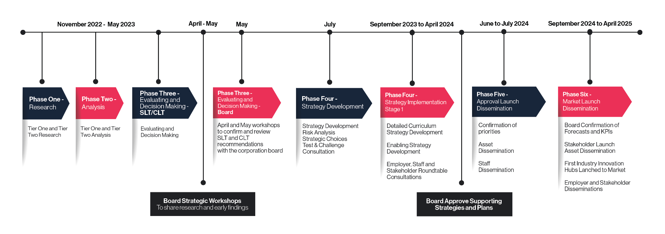

In the period following the establishment of the five-year strategy, there has been thorough, detailed and on-going engagement with stakeholders to inform the key priorities and ensure we are continuing to meet both previously established and emerging needs. On-going industry board input continually shapes curriculum, with eight sectoral boards and a specialist Lancashire Adult Learning advisory board providing both strategic and more detailed direction.

The direction provided by employers and stakeholders through the regular convening of industry boards contributes to the detailed and extensive research carried out by heads of curriculum as part of the annual curriculum planning process, which takes a two-year view of delivery plans. Plans are designed using – and tested against - a broad range of evidence including

- Lancashire LSIP
- Lancashire Growth Plan
- Get Britain Working
- UK Industrial Strategy
- Education and Skills White Paper
- Sector employer representative bodies
- Local authorities.

These plans are then realised and implemented through a process of co-creation which is evidenced through detailed curriculum delivery planning.

The Lancashire Colleges group provides a sub-regional mechanism for planning responses to skills needs, with examples of this being LSIFs and the Lancashire Institute of Technology. Most recently, through ELLG’s role in the North-West CTEC, we are supporting other providers across Lancashire to meet the construction skills needs identified in both the LSIP and the UK Industrial Strategy.

In addition to the on-going work with employers, East Lancashire Learning Group regularly reviews emerging policy through weekly full SLT meetings and SLT sub-groups and incorporates them into the implementation or enabling plans that sit beneath the over-arching strategic plan. The East Lancashire Learning Group Board oversees these plans through full board meetings, sub-committees and two strategic events in each academic year. As such, in addition to approving the Accountability Agreement, the Corporation Board have also approved the college’s two-year curriculum plan 2026/28 and the Strategic Transition Planning Statement, following SLT-facilitated workshops reviewing strategy alignment to the Post-16 Skills White Paper, SEND reform consultation, Qualification Reform and Lancashire County Combined Authority adult skills devolution plans.

Following the Strategic Review in 2023, a board review and skills audit and succession plan were developed. This resulted in a full board refresh, with new board members recruited from key industrial sectors and essential skill backgrounds to ensure that the board has both the capacity and skills to drive the strategic plan and ensure SLT accountability.

3. Contributions to National, Regional and Local Skills Priorities
As part of business and curriculum planning, the college has undertaken a strategic alignment activity to ensure that curriculum continues to align with national and regional priorities. In response to recent curriculum reform announcements, following the Curriculum and Assessment Review and Post-16 White Paper, we are also ensuring that planning for new T Levels and V Levels supports continuity of provision in key sector areas.

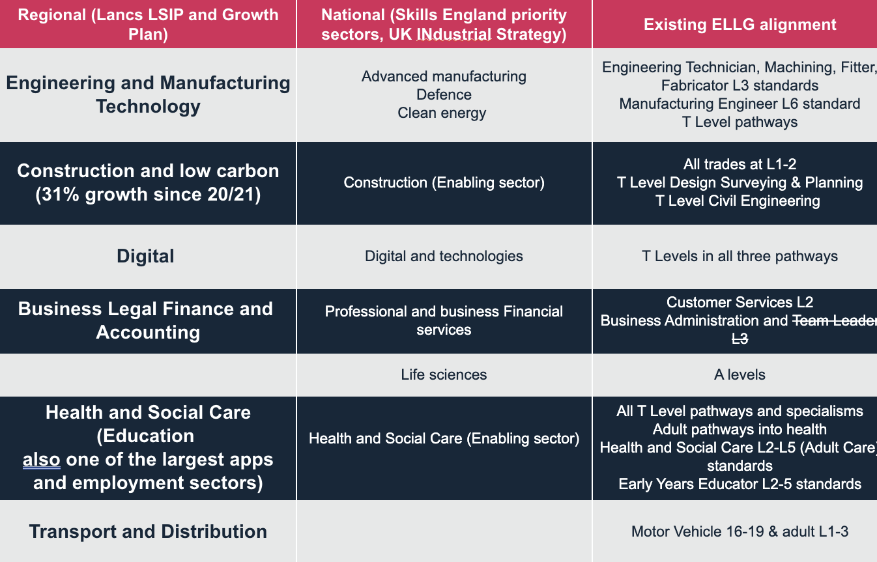

16-18 Study Programmes
As a wave 1 T Level trailblazer, the College has a mature and well-established T Level offer across a range of key routes, including in the regional priority sectors identified in the LSIP of digital, health, engineering and manufacturing and construction. In alignment with the College’s strategic plan, the College has an ambitious strategy around the growth of T Levels over the period 26/27 to 28/29, supported by significant investment in facilities and extensive collaboration with employers. Underpinning the strategy is a focus on meeting the specific technical skills needs of employers in the largest sectors in East Lancashire, including in healthcare, advanced manufacturing, construction and digital. The T Level curriculum is co-designed with employers to ensure learners develop the knowledge, skills and behaviours they need to progress into technical employment in their occupational specialisms, the success of which has already been evidenced by the destinations of the 2022, 2023 and 2024 T Level graduates. As such, the college is in a strong state of preparedness for qualification reform and doesn’t anticipate any significant challenges, whilst acknowledging that industry placement scaling does require significant further investment.
Technical study programmes are structured to include a substantial core qualification, English and maths where required, personal development and meaningful industry placement or work experience, ensuring learners are prepared for employment and progression. At Level 3, programmes are delivered as two-year study programmes with extensive employer involvement, ensuring that content reflects current industry practice and supports progression into higher technical routes. The curriculum also embeds the “Work Ready Lancashire” employability framework, ensuring learners develop the wider skills and behaviours valued by employers.

Adult Curriculum
The adult curriculum is designed to be flexible, accessible and highly responsive to the needs of individuals, communities and employers across the Lancashire footprint. It aligns with national and regional priorities, including skills, productivity, social mobility and wellbeing agendas, as well as local strategies such as the Lancashire Skills and Employment Framework, LSIP and Get Lancashire Working priorities. Strong partnerships with employers, community organisations and stakeholders ensure that provision reflects both economic priorities and community need, particularly in disadvantaged areas.
The curriculum is structured to specifically meet the needs of the newly-formed Lancashire Combined County Authority to support adults to gain new skills, progress in work, retrain or re-engage with learning, with a clear focus on improving life chances. English, maths and digital skills are embedded across all programmes, recognising their importance in enabling progression into employment and further learning. Teaching is sequenced and personalised, allowing learners to build knowledge, skills and confidence from their starting points and progress towards clearly-defined next steps.
The provision meets local and regional needs effectively, demonstrated through:
- A broad and flexible offer that supports progression into employment or further learning
- Strong focus on employability, upskilling and reskilling, aligned to labour market demand
- Targeted provision for disadvantaged and hard-to-reach learners, supporting social mobility and inclusion
- Delivery of community learning programmes that address health inequalities, wellbeing and family learning needs.
The adult curriculum contributes to local and regional priorities by:
- Supporting adults to enter, re-enter or progress within the workforce, particularly in priority sectors
- Delivering skills-based provision aligned to economic need and the Skills for Growth agenda
- Improving English, maths and digital capability, addressing key barriers to employment
- Providing local, community-based, tailored learning that supports wellbeing, resilience and social integration, as stated in the Skills for Life agenda
- Enabling progression to higher-level study, including Access to Higher Education programmes

Apprenticeships
The apprenticeships provision has been reshaped over the last two years to more effectively focus on the priorities identified in the Lancashire LSIP. Co-creation with employers is taking place across curriculum areas to ensure alignment with local needs. Analysis of the priority areas indicates a greater need in the construction industry and a shortfall in provision to meet this need, especially across Hyndburn and Rossendale. Investment in facilities and equipment taking place during summer 2026 will support programme expansion to generate construction workforce growth and enable the progression to apprenticeships of full-time 16-19 students in the priority areas of carpentry and joinery, electrical installation and plumbing and heating.
As one of the largest employment sectors in East Lancashire, engineering and manufacturing remains a priority for ELLG. Focused growth and tailored co-created apprenticeship provision will continue to be developed in collaboration with employers.
ELLG apprenticeships provision meets local and regional priorities by:
- A high-quality offer that focuses on the largest priority sectors across Lancashire

- A strong focus on a tailored offer that meets the needs of individual employers

Higher Education
At East Lancashire Learning Group our ambition is to create ladders to Level 4 technical education in key LSIP priority sectors enabling more adults and young people to access Level 4/5 technical occupations. The college serves local communities across East Lancashire, predominantly from Accrington and Nelson, and attracts a large proportion of adults from the most disadvantaged quintiles 1 and 2. Progression into professional employment or further study in 2022/23 for first degree level students is 79%, 5% above the sector average.
The latest OfS Student Outcomes data shows continuation for East Lancashire Learning Group full-time first-degree students at 79.3%. Although this sits below the OfS benchmark of 83.8%, the Group performs favourably when compared with comparable local college-based HE providers. Improving continuation remains a key priority, supported through enhanced in-year monitoring, attendance and engagement tracking, in addition to targeted interventions to support students to remain in study and achieve successful outcomes.

NEET Local Context and Strategic Response

East Lancashire Learning Group recognises the growing challenge presented by young people aged 16–24 who are not in education, employment or training (NEET), both nationally and within Lancashire. Recent data indicates that 3.9% of young people across Lancashire-12 are categorised as NEET, above the national average of 3.4%, with significant increases evident in districts including Burnley, Chorley and Lancaster. We acknowledge that this is no longer solely an issue of short-term disengagement, but increasingly one of sustained detachment from education, employment and wider support systems. In response, the college is strengthening its role as an early intervention and preventative provider, working collaboratively with local authorities, schools, employers and community partners to identify risk earlier and support young people through flexible, inclusive and purposeful pathways. Our strategic approach focuses on ensuring that learners facing the greatest barriers can access provision that is appropriate, ethical and effective, supporting meaningful progression into further learning, employment or training rather than repeated cycles of re-engagement. We are committed to delivering targeted, high-quality support in a way that is operationally and financially sustainable, making intentional use of existing partnerships and curriculum pathways to maximise local impact and improve outcomes for vulnerable young people.
Strategic Delivery Timeline
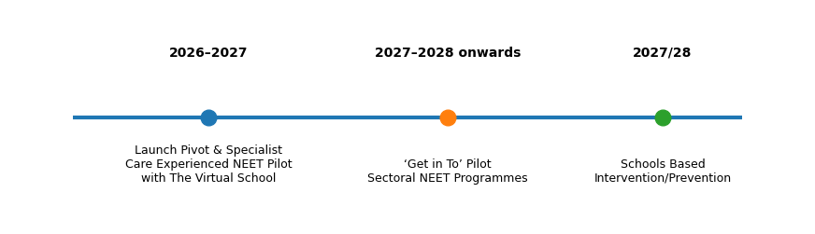

Strategic timeline illustrating phased NEET prevention, intervention and progression initiatives.

Inclusion

The College will use the Inclusive Mainstream Fund (IMF) funding to strengthen its inclusive mainstream provision for 16 to 19 learners. This includes investment in high-quality, adaptive teaching, inclusive learning environments and early identification and support for learners with additional needs.
The College’s approach focuses on enabling learners to participate successfully in mainstream programmes, build independence and progress to positive destinations. IMF funding complements, but does not replace, High Needs or EHCP-based provision, and is deployed in line with shared local expectations agreed with partners. The College works collaboratively through The Lancashire Colleges partnership to support coherent post-16 pathways across the county, share effective inclusive practice and avoid unnecessary duplication, ensuring learners can access the provision that best meets their needs.

Key Actions for 2026/27
Participation in National Priority Programmes
We will:
- Continue to grow learner volumes in priority T-Level programmes including Construction Design Surveying and Planning and Civil Engineering.
- Introduce level 2 Electrical Installation in line with national and regional priorities and local need.
- Increase the overall volume of learners studying T Levels at East Lancashire Learning Group by a further 10%.
- Further develop the curriculum offer in order to respond to the NEET profile of the ELLG Accrington and Rossendale and Nelson and Colne campus areas.
Participation in Regional (LSIP) Skills Priorities
We will:
- Launch and run a new 16-18 study programme in Plumbing and Heating at Level 1/2 recruiting an initial group of 10 learners.
- Contribute to fulfilling Lancashire County Combined Authority priorities for target groups and geographic locations through delivery of ‘skills for growth’ and ‘skills for life’ programmes.
Quality Improvement
We will:
- Increase retention rates on priority sector apprenticeship programmes by a further 5%.
- Achieve a successful outcome in the ITE Ofsted inspection.

Regional Contribution
We will:

Contribute to the growth of skilled workers entering the construction sector in the North-West through developing the skills of construction teachers and leaders through our role as a Construction Technical Excellence College (CTEC) partner.

Performance against Key Actions for 2025/26.
Update on Key Actions for 2025/26

Participation in National Priority Programmes | 2025/26 Update
Continue to expand the T Level curriculum offer introducing an initial pathway Civil Engineering within the Construction & Built environment route | Course introduced and cohort of 6 learners enrolled
Increase the overall volume of learners studying T Levels at East Lancashire Learning Group by a further 20% to 190 in total | 30.5% increase achieved
Triple the number of learners enrolled in HTQs, significantly expanding access to industry-relevant skills and training | 157% increase achieved
Participation in Regional (LSIP) Skills Priorities | 2025/26 Update
Launch and run a new 16-18 study programme electrical installation offer at Level 1/2 recruiting an initial group of 15 learners | Level 1 Group launched with 21 enrolled learners
Increase the volume of learners enrolled on Engineering programmes (Level 2+) at Nelson and Colne College Group by 20% | 12% increase achieved
Quality Improvement | 2025/26 Update
Reduce the number of withdrawals on Apprenticeship programmes by 10% | 31.7% reduction achieved
Reduce the number of learners past their planned end date by 180 days or more by 10% | Reduction of 44% has been achieved

Part Five - Local Needs Duty
This statement is a summary of the extensive review – and the ongoing annual reviews - that have taken place – to ensure provision across the college aligns with and responds to local needs, now and over the remaining years of the strategic plan. The key sectors identified through both the LSIP and four months of extensive employer and stakeholder engagement were incorporated into the college’s strategic curriculum planning, and are supported by focused enabling strategies and investment to effect swift implementation of relevant curriculum along with continuous stakeholder and employer engagement.
The outcomes of the strategic review are reviewed annually and updated to ensure key actions are current and prioritised. This ongoing review of strategy further strengthens the college’s response to meeting local skills priorities. The strategic curriculum plan is delivering the introduction or expansion, of provision that links to the LSIP, including manufacturing, construction, digital and low carbon, with electrical installation and plumbing being introduced and extended over the summer of 2026. It is also strengthening qualification reform readiness across the component parts of the group. An integrated sectoral approach to the development of curriculum is being implemented to continue to create linked pathways through 16-19, apprenticeship, adult and HE to enable learners to develop relevant skills and move swiftly into employment and further training. In response to devolution in Lancashire, the college has continued to build on its nationally-recognised, impactful adult learning with the expansion of its skills provision across key sectors.

Part Six - Corporation Statement
On behalf of the Corporation of the Nelson and Colne College Group, we confirm that having completed a Strategic Review of the College’s performance and offer aligned to local area need, this Accountability Statement reflects an agreed statement of purpose, aims and objectives as approved by the Corporation at their meeting on 20th May 2026.|

Phil Wilkinson  Chair of the Board of Corporation |  | Lisa O’Loughlin  Principal and Chief Executive Officer (CEO)

Part Seven - Accountability Statement
The Accountability Statement will be publicly available on the College Group’s website within three months of the new academic year and can be accessed from clicking here.
Part Eight - Links to Supporting Documents
https://www.lancashirelsip.co.uk/downloads/LSIP_Report_31%20March%202022_Website_Publication.pdf
https://www.lancashire.gov.uk/lancashire-insight/area-profiles/

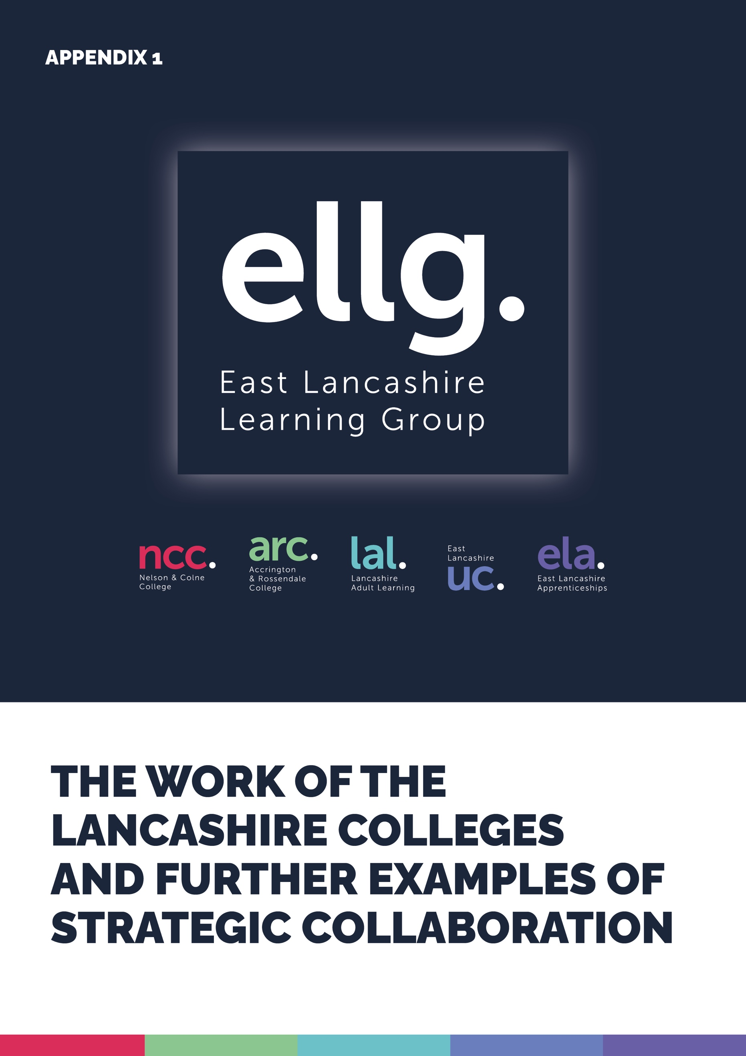
The Lancashire Colleges - Key Facts
9,000  BUSINESSES SUPPORTED | Lancashire’s colleges have extensive networks of public and private sector partners and currently work with 9,000 businesses, supporting their staff in apprenticeships and other training. Lancashire’s colleges achieve above average scores for employer satisfaction.
£288  MILLION | With a combined turnover of almost £288 million, Lancashire’s colleges are major employers in their own rights, employing around 6,000 people, making a significant contribution to the local economy.
£1=£15 | For every pound of government funding invested, Lancashire’s colleges deliver over £15 in economic benefits over their students’ lifetime, a substantial return.
82,000  YOUNG AND ADULT LEARNERS | Lancashire’s colleges provide education and training to over 82,000 young and adult learners each year from Entry Level to postgraduate and across a spectrum from the most disadvantaged to the most able.
OVER  8,000 | Over 8,000 or 12% of all higher education (HE) students based in Lancashire study at Lancashire’s colleges compared with 4% of HE students being based in colleges nationally. Three of the Lancashire Colleges are in the top ten largest HE in FE providers nationally.
£13 MILLION  EXTERNAL FUNDING | TLC has secured over £13 million of external funding in 2021/22 for the benefit of Lancashire.

Examples of Strategic Collaboration
The college is a strategic partner in the North-West CTEC, responsible for the delivery of CPD in teaching and learning across the NW providers. This is in response to local and regional needs and sees the college convening and collaborating with the Lancashire providers and more widely to raise the standard of teaching and learning, leadership and mentoring across construction provision. The CTEC, launched in 25/26, is a four-year project and aims to increase the skilled workforce across all aspects of construction, including skilled trades, green skills and construction professions.
Between 2024-25 and 2025-26 the college collaborated closely with four NW FE providers, Edge Hill University and The Gatsby Foundation to develop and deliver an Industry Associates programme aimed at increasing the number of industry technical experts moving into teaching or contributing to curriculum teaching in key sector areas aligned with LSIP priority needs. The successful programme has been endorsed by the Post-16 Skills white paper and has been approved for a national launch.
A £4.5m Local Skills Improvement Fund (LSIF) Programme (2023-25) through which we are working in partnership with local colleges to respond to skills priorities highlighted in the Lancashire Local Skills Improvement Plan (LSIP) including green construction skills, digital employability skills and pathways to employment in the food, hospitality and farming sectors.
A £9m Strategic Development Fund (SDF) Pilot Programme (2021-22) saw Lancashire’s colleges collaborating with each other to help provide the skills businesses need as they respond to the challenges and opportunities presented by the shift towards net-zero carbon. This programme recognised the importance of Lancashire’s Energy and Low Carbon sector as emphasised in the the Lancashire Independent Economic Review and supported and enabled businesses to respond to market and technological change, a priority highlighted in Lancashire’s Technical Education Vision.
A £2.75m Phase 2 SDF project (2022-23) allowed the colleges to continue our joint work on net-zero carbon curriculum development and also allowed a focus on cyber-security. The latter was in direct response to not only the announcement that the National Cyber Force will be located in Lancashire, recognising the impact this will have on clusters and supply chain development, but also on feedback from SMEs that cyber-security is a significant area of concern.
Through an ESF ‘Moving On’ project (2016-23) the colleges across Lancashire have collaborated with private and third sector providers to support over 5,500 young people who were NEET/at risk of becoming NEET, a priority group for the Lancashire Combined County Authority. Nearly 60% of young people progressed or were retained in education, skills or employment as a result of this support.
The ESF ‘Supporting Technical Education in Lancashire’ project (2021-22) supported over 330 Lancashire-based SMEs to engage in technical education and training. This project directly responded to feedback from local employers that they needed more support to understand how they could engage in technical education through offering work placements or apprenticeships, by getting involved in designing curriculum and offering masterclasses.
A small pilot project (2021-22) saw the establishment of four Professional Development Networks bringing together over 130 teaching staff from across the colleges to develop their Level 4/5 subject and pedagogic content knowledge and create teaching and other resources. This helped to improve the quality of technical and professional curriculum design, teaching, learning and assessment across four local priority sectors: construction, health, sustainable energy and ecology/land-based.


